**OUTREACH SCHOOLS EXAMINATION BOARD**

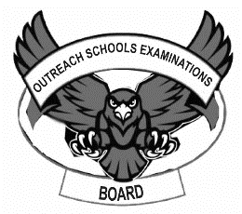 **END OF TERM I EXAMINATION 2024**

**PRIMARY ONE**

**LITERACY II**

**My name is …………………..………………….……………………**

**I am in …………………………..………..……….………………….**

**My school is …………………..………...…………………………**

1. **Read these vowel sounds.**

o, a, i, e, u (10 mks)

1. **Read these sounds.**

s, te, m, ca, p (10 mks)

1. **Read these sounds**. (10mks)

bus , fish, pen

hospital, mother. (10mks)

1. **Read these sentences.**
2. Ben is eating an egg.
3. Fifi has a fish.
4. Sese is sleeping. (20mks)
5. It is a box.
6. Papa has a car.
7. **Read the story correctly.**

My mother is a nurse. She has a fat baby. The baby’s name is Nana. Nana likes eating eggs. She has a big doll.

(50mks)